Blickling Parish Council
https://www.hugofox.com/community/blickling-parish-council-15098/home
email: blicklingpc@gmail.com
NOTICE OF MEETING & SUMMONS TO ATTEND
THE NEXT MEETING OF BLICKLING PARISH COUNCIL WILL BE HELD AT BLICKLING HALL
At 7.30pm on Monday May 15th 2023
AGENDA
Members of the public are welcome to attend and may speak during the adjournment.
1. TO ELECT THE CHAIRMAN OF THE COUNCIL FOR 2022/23

2. TO RECEIVE THE CHAIRMAN’S DECLARATION OF ACCEPTANCE OF OFFICE

3. TO SET A FINAL DATE FOR COMPLETION OF COUNCILLORS FORMS
a) To note receipt of councillors Declaration of Acceptance of Office
b) To set a date for any outstanding Declarations

4. TO RECEIVE & ACCEPT APOLOGIES FOR ABSENCE

5. TO ELECT THE VICE-CHAIRMAN OF THE COUNCIL FOR 2022/23

6. TO CONSIDER ADOPTION OF NEW CODE OF CONDUCT
a) To consider adoption of Broadland Code of Conduct
b) To note Register of Interest Forms need to be completed electronically
c) To note final date for competition of Register of Interest Forms

7. TO RECEIVE MEMBERS' DECLARATIONS OF INTEREST IN AGENDA ITEMS

8. MINUTES
To receive, confirm and sign Minutes of the last meetings held on 13th March 2023

9. INFORMATION ON MATTERS ARISING
To receive information on any Matter Arising from the Minutes of the previous meeting
10. REPORTS POLICE, COUNTY AND DISTRICT COUNCILLORS
To receive written and/or verbal Reports from Representatives

11. TO ADJOURN THE MEETING FOR MEMBERS OF THE PUBLIC TO SPEAK
Adjournment for public discussion

12. FINANCE AND AUDIT
a) To approve the accounting Statement for the year ended 31st March 2023
b) To note balance of account
c) To complete AGAR Exemption certificate for 2022/23
d) To consider payments to be made
- Zurich Insurance £168.00
- Blickling PCC £300.00
- Mrs S Lake £300.00

13. TO CONSIDER PLANNING ISSUES
To discuss any planning applications received

14. BLICKLING CEMETERY AND PCC
a) To receive an update on PCC Accounts
b) To receive an update on the provision of bench

15. TO CONSIDER HIGHWAY ISSUES
a) To receive an update on parking in Silvergate
b) To discuss Silvergate residents response to White H Lines etc
c) To discuss any other highway matter

16. NATIONAL TRUST
To receive any update

17. NOTICEBOARDS
To receive an update

18. COMMUNITY EVENTS
a) To receive an update on the seeds project to commemorate the coronation of King Charles lll
b) To consider a community picnic

19. TO NOTE ITEMS FOR INFORMATION/FUTURE AGENDA

20. DATE OF NEXT MEETING
To agree the dates of the meetings for the coming year.
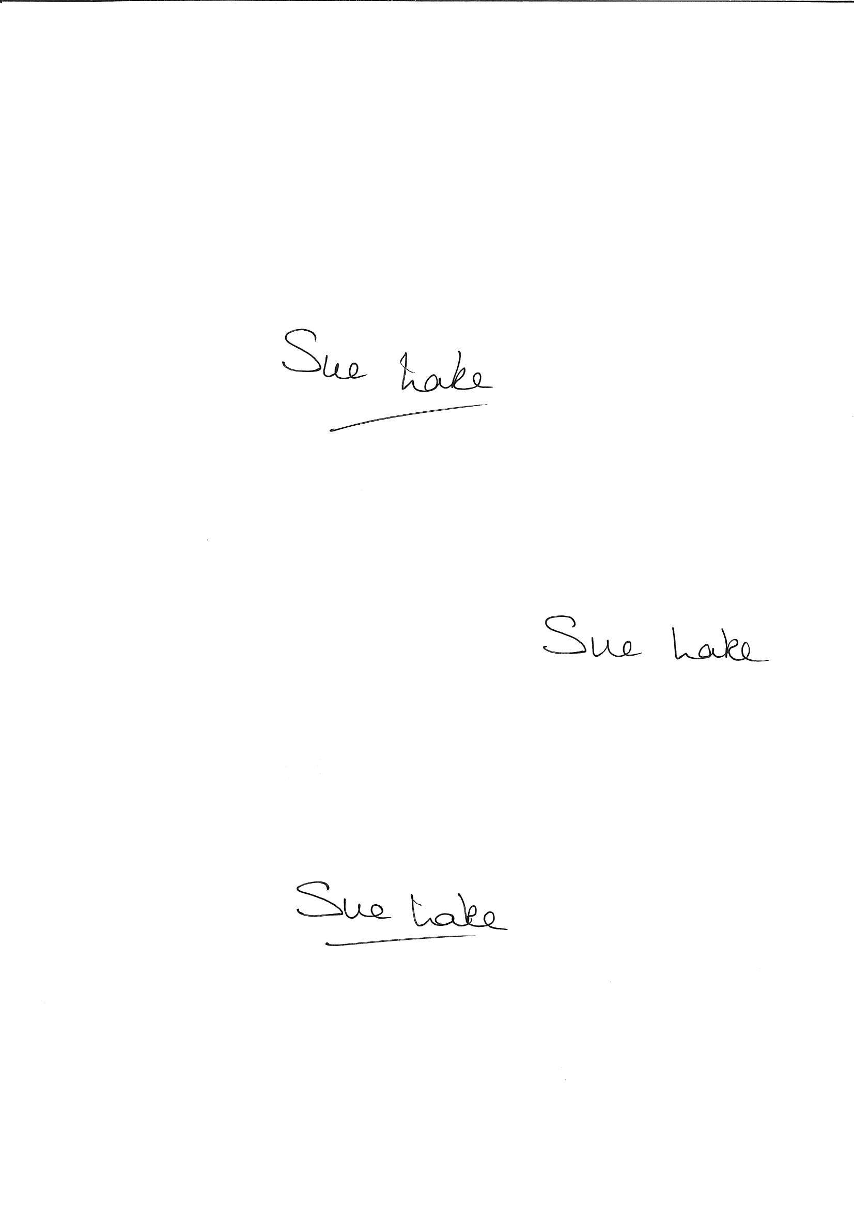
Sue Lake
Locum Clerk 8th May 2023

