Blickling Parish Council
https://www.hugofox.com/community/blickling-parish-council-15098/home
email: blicklingpc@gmail.com
NOTICE OF MEETING & SUMMONS TO ATTEND
THE ANNUAL MEETING OF BLICKLING PARISH COUNCIL WILL BE HELD AT BLICKLING HALL
At 7.30pm on Monday May 13th 2024
AGENDA
Members of the public are welcome to attend and may speak during the adjournment.
1. TO ELECT THE CHAIRMAN OF THE COUNCIL FOR 2024/5

2. TO RECEIVE THE CHAIRMAN’S DECLARATION OF ACCEPTANCE OF OFFICE

3. TO RECEIVE & ACCEPT APOLOGIES FOR ABSENCE

4. TO ELECT THE VICE-CHAIRMAN OF THE COUNCIL FOR 2024/5

5. TO RECEIVE MEMBERS' DECLARATIONS OF INTEREST IN AGENDA ITEMS

6. MINUTES
To receive, confirm and sign Minutes of the last meetings held on 12th February 2024

7. INFORMATION ON MATTERS ARISING
To receive information on any Matter Arising from the Minutes of the previous meeting

8. REPORTS POLICE, COUNTY AND DISTRICT COUNCILLORS
To receive written and/or verbal Reports from Representatives

9. TO ADJOURN THE MEETING FOR MEMBERS OF THE PUBLIC TO SPEAK
Adjournment for public discussion

10. FINANCE AND AUDIT
a) To approve the accounting Statement for the year ended 31st March 2024
b) To note balance of account
c) To complete AGAR Exemption certificate for 2023/4
d) To consider payments to be made
- Zurich Insurance £168.00
- Mrs S Lake £300.00

11. TO CONSIDER PLANNING ISSUES
To discuss any planning applications received

12. TO CONSIDER HIGHWAY ISSUES
a) To receive an update on parking in Silvergate
b) To consider cost and size of No Parking signs
c) To receive an update on the passing places
d) To receive an update on hedge on Silvergate
e) To note residents issues with pig farm traffic
f) To discuss any other highway matter

13. NATIONAL TRUST
a) To receive details of the stakeholders meeting
b) To note comments received regarding parking charges for weddings/funerals
To receive any update

14. COMMUNITY EVENTS AND COMMUNICATIONS
a) To receive an update on the Farm Walk
b) To receive an update on the website
c) Communication with residents – Facebook – E-mail – Newsletter

15. WINDFARMS
To receive an update

16. TO NOTE ITEMS FOR INFORMATION/FUTURE AGENDA

17. DATE OF NEXT MEETING
To agree the dates of the meetings for the coming year.
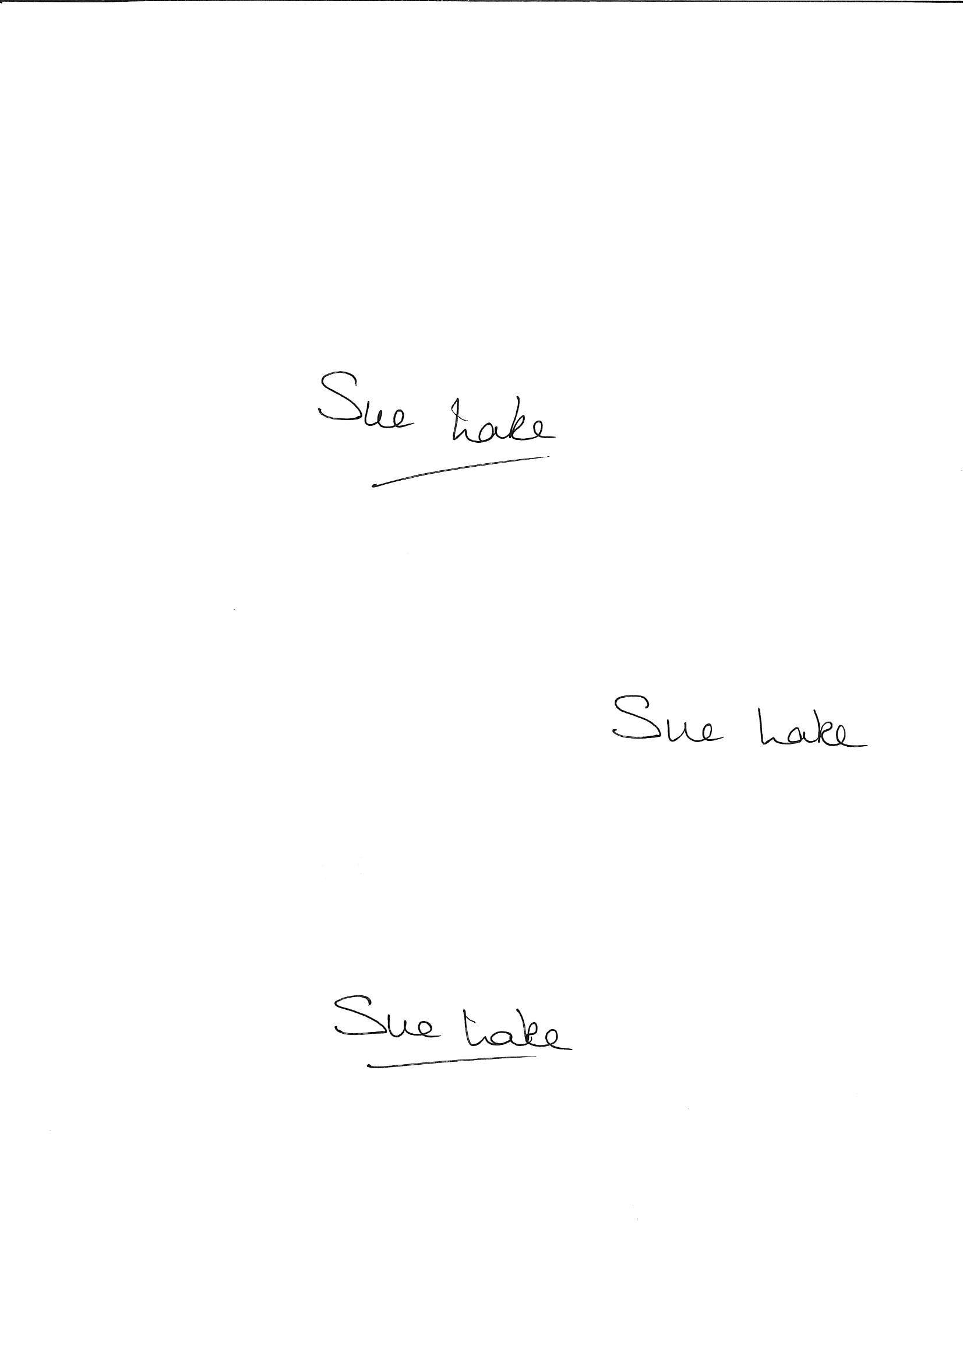
Sue Lake
Parish Clerk 7th May 2024

